### What is Linux?

* Linux is an operating system just like Windows, iOS, and Mac OS.
* In fact, Android, one of the world's most popular platforms, is operated by the Linux operating system.
* An operating system is a software that manages all of your desktop or laptop's hardware resources. To put it simply, the operating system manages the communication between your software and your hardware. The software would not operate without the operating system (OS).

### The History of Linux

* Linus Torvalds invented Linux. While still a student at the University of Helsinki, he started developing Linux to create a system similar to MINIX, a UNIX operating system. In 1991 he released version 0.02; Version 1.0 of the Linux kernel, the core of the operating system, was released in 1994. At about the same time, American software developer Richard Stallman and the FSF made efforts to create an open-source UNIX-like operating system called GNU. In contrast to Torvalds, Stallman and the FSF started by creating utilities for the operating system first. These utilities were then added to the Linux kernel to create a complete system called GNU/Linux, or, less precisely, just Linux.
* Linus announces the kernel to the world (1991).
* Release of the first "major" Linux distributions (1993).
* Linux kernel hits 1.0 (1994).
* KDE (1996) / GNOME (1999) projects are released.
* First release of Linux-based Android (1998).
* Kernel development moves to Git (2005).
* Today Linux is everywhere. Supercomputers, smartphones, desktop, web servers, tablets, laptops and home appliances like washing machines, DVD players, routers, modems, cars, refrigerators, etc use Linux OS.

### The components of Linux

There are several components of the Linux operating system.

### Hardware: Computer hardware is the physical components that a computer system requires to function. It encompasses everything with a circuit board that operates within a PC or laptop; including the motherboard, graphics card, CPU (Central Processing Unit), power supply, and so on.

### Boot-loader: The software that manages the boot process of your computer.

### Kernel: It is the core part of the operating system and manages the CPU, memory, and peripheral devices. The kernel is the lowest level of the OS.

### GNU Core: The GNU Core Utilities are the basic file, shell and text manipulation utilities of the GNU operating system. These are the core utilities that are expected to exist on every operating system.

### X server: This is the sub-system that displays the graphics on your monitor. It is commonly referred to as the X server or just X.

### Graphical User Interface: The Linux GUI is often referred to as a Desktop Environment. This is the piece that the users actually interact with. Several desktop environments are available to choose from (GNOME, Cinnamon, Mate, Pantheon, Enlightenment, KDE, Xfce, and so on).

### Applications: Desktop environments do not have the full range of applications available. Just like Windows and macOS, Linux provides thousands upon thousands of software titles of high quality that can be easily found and installed.

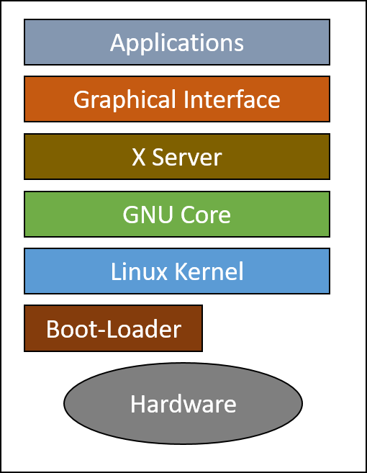

### Popular Linux Distributions

Linux has a number of different versions to suit any type of user. These versions are called distributions (or, in the short form, “distros”).

## Linux Mint

## Debian (Distribution that appeared first)

## Ubuntu

## OpenSUSE

## Manjaro

## Fedora

## Red Hat Enterprise Linux (RHEL)

**Linux Embedded Systems**

* **Embedded System :** An embedded system is a computer system that is dedicated to one or two specific functions. This system is embedded as part of a complete computer system including hardware such as mechanical and electrical components.
* **Embedded Linux** is a type of Linux operating system/kernel that is designed to be installed and used within embedded devices and appliances. It is a compact version of Linux that offers features and services in line with the operating and application requirement of the embedded system.
* Android OS is a type of embedded Linux, customized to be used on smartphones. Many systems that use Linux embedded are:
* Smart TVs
* Tablet PCs
* Navigation devices
* Wireless routers
* Other industrial and consumer electronic equipment

## Open-Source Software and Licensing

### What is open source?

* Open-source software is **software with source code that anyone can inspect, modify, and enhance**.
* "Source code" is the part of software that most computer users don't ever see; it's the code computer programmers can manipulate to change how a piece of software—a "program" or "application"—works. Programmers with access to the source code of a computer program can enhance the system by adding features to it or repairing sections that don't always work properly.

## How does open-source software vary from other types of software?

* Most software has source code that can be changed only by the individual, team, or organization that developed it — and retains sole control over it. That type of software is called "**proprietary**" or "**closed source**" software.
* Only the original authors of proprietary software can legally copy, inspect, and alter that software. And in order to use proprietary software, computer users must agree (**usually by signing a license** displayed the first time they run this software)
* Open-source software is different. Its authors **make its source code available to others who would like to view that code, copy it, learn from it, alter it, or share it**. LibreOffice and the GNU Image Manipulation Program are examples of open-source software.

**Open-source Licensing**

Open source licenses are licenses that comply with the Open Source Definition — in brief, they allow the software to be freely used, modified, and shared. To be approved by the Open Source Initiative (also known as the OSI), a license must go through the Open Source Initiative's license review process.

## Free Software Foundation (FSF)

* The Free Software Foundation (FSF) is a nonprofit with a worldwide mission to promote computer user freedom.
* Free Software Foundation (FSF) is led by Richard Stallman.
* Free software is **about having control over the technology we use** in our homes, schools, and businesses, where computers work for our individual and communal benefit, not for proprietary software companies or governments who might seek to restrict and monitor us. The Free Software Foundation exclusively uses free software to perform its work.

## Open Source Initiative (OSI)

* The Open Source Initiative (OSI) is a non-profit organization dedicated to the promotion of open-source software.
* OSI was founded in 1998 by Bruce Perens and Eric Raymond. OSI is quite distinct from the Free Software Foundation (FSF) led by Richard Stallman. Although they have similar history and motivation, OSI considers its ends as more pragmatic and business-driven, while FSF is based on anti-establishment and moralistic viewpoints. The OSI is actively engaged in building open source community, public advocacy, education, and promoting awareness regarding the significance of non-proprietary or open-source software.

## Major Open-Source Applications

## Desktop Applications:

## Firefox: Mozilla Firefox, also known as the Firefox browser, or simply Firefox, is a free and open-source web browser developed by the Mozilla Foundation and its subsidiary, Mozilla Corporation.

## Thunderbird: Thunderbird is a free and open-source email, newsfeed, chat, and calendaring client, that’s easy to set up and customize.

## LibreOffice: LibreOffice is free and open-source software, originally based on OpenOffice.org (commonly known as OpenOffice), and is the most actively developed OpenOffice.org successor project.

## GIMP: GIMP is an acronym for GNU Image Manipulation Program. It is a freely distributed program for such tasks as photo retouching, image composition, and image authoring.

## Server Applications:

* **Apache Web Server:** Apache Web Server is an open-source web server creation, deployment, and management software.
* **NGINX:** NGINX is open-source software for web serving, reverse proxying, caching, load balancing, media streaming, and more.
* **MySQL:** MySQL was a free-software database engine originally developed and first released in 1995. MySQL is very popular for Web-hosting applications because of its plethora of Web-optimized features like HTML data types, and because it's available for free.
* **Samba:** Samba is an open-source software suite that runs on Unix/Linux based platforms but can communicate with Windows clients like a native application.
* **ownCloud:** ownCloud is a client-server suite of applications for creating and using file hosting service.

### Development Languages

## Shell: Shell is a command language interpreter that executes commands read from the standard input device such as a keyboard or from a file. A shell script is a list of commands in a computer program that is run by the Unix shell. The most common Linux shell is named Bash. The name is an acronym for Bourne-again shell. Bash (like many other shells) has the ability to run an entire script of commands, known as a "Bash shell script" (or "script").

## C: C is a high-level and general-purpose programming language used for a wide range of applications from operating systems like Windows and iOS to software that is used for creating 3D movies.

## Java: Java is a high-level programming language originally developed by Sun Microsystems and released in 1995. Java runs on a variety of platforms, such as Windows, Mac OS, and the various versions of UNIX. Java is Platform Independent, portable, robust, and dynamic, with the ability to fit the needs of virtually any type of application

## JavaScript: JavaScript is a high-level, cross-platform, object-oriented computer programming language. It is also one of the core technologies of the web, along with HTML and CSS. JavaScript is used to create client-side dynamic web pages. Java and javascript are completely different and distinct languages.

## Perl: Perl is a highly capable, feature-rich programming language with over 30 years of development. Perl runs on over 100 platforms from portables to mainframes and is suitable for both rapid prototyping and large scale development projects.

## Python: Python is a high-level programming language, with applications in numerous areas, including web programming, scripting, scientific computing, and artificial intelligence. Python has extensive object-oriented programming support with a clean and consistent syntax.

## PHP: PHP is a popular general-purpose scripting language that is especially suited to web development. Fast, flexible and pragmatic, PHP powers everything from your blog to the most popular websites in the world.

**Command Line Basics**

What is the "Shell"?

* Shell is an interface between an end-user and the Linux system.

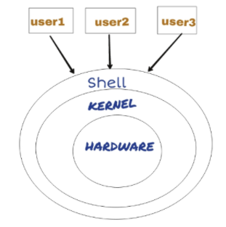

* In other words, Shell is a program that receives commands from the user, relays them to the operating system to process and displays the output. Shell is one of the main parts of Linux OS. Each Linux distro comes with a GUI (Graphical User Interface), but essentially Linux has a CLI (Command-Line Interface).

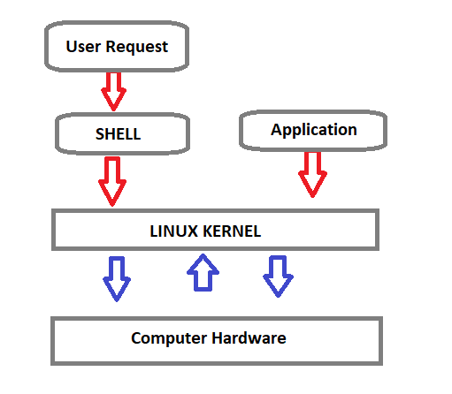

**Shell Types**

**C Shell:** If you are using a C-type shell, the % character is the default prompt.

* C shell (csh)
* TENEX/TOPS C shell (tcsh)

**Bourne Shell:** If you are using a Bourne-type shell, the $ character is the default prompt.

* Bourne shell (sh)
* Korn shell (ksh)
* Bourne Again shell (bash)
* POSIX shell (sh)

An enhanced version of SH is called BASH (which stands for **B**ourne **A**gain **SH**ell) and serves as the main shell program on the most Linux systems.

* **The standard Linux shell (BASH) is both a command-line interpreter and a programming language.**
* **The most common interpreter is BASH** or the Bourne Again Shell, but there are others available as well and some of them does not use the dollar sign.

**Command Prompt:**

* The command prompt at the beginning of the command line **is** **a short text string**. The command prompt for Linux generally shows the current **user**, the current **host**, and the ppropriate **directory**.
* The command prompt is easily modified to display as desired with more or less information.
* At the end of the prompt list, **the $(dollar sign) signifies the current user being unprivileged.** Dollar sign ($) means you are a normal user and indicates you are logged in with the normal permissions.
* **Hash (#)** means you are the system administrator (root) and indicates **you are logged in with root privileges**.
* The "**root**" account on a Linux computer **is the account with full privileges**. Root access is often necessary for performing commands in Linux, especially commands that affect system files. Because root is so powerful, **it's recommended to only request root access when necessary**, as opposed to logging in as the root user.

**Basic Shell Commands**

This is **a list of most frequently used Linux commands**.

* The **~ (tilde)** symbol stands for your home directory.
* The **pwd** (stands for print working directory) command will allow you to know in which directory you're located.
* The **ls** command will show you the list of folders and files in your current directory.
* The **cp** command will make a copy of a file.
* The **cd** command will allow you to change directories.
* The **rm** command removes or deletes a file in your directory.
* The **rmdir** command will delete an empty directory.
* The **mkdir** command will allow you to create directories
* The **mv** command will move a file to a different location or will rename a file.
* cd - Navigate to the last directory you were working in.
* cd ~ or just cd Navigate to the current user's home directory.
* cd .. Go to the parent directory of current directory (mind the space between cd and ..)

### Quoting: Quoting is used to disable special treatment of certain characters and words, as well as to prevent parameter expansion and preserve what is quoted.

The bash shell knows rare, special characters like $ (dollar sign), which is used to extend the value of the element. For example $PATH is used to extend the value of PATH element which is predefined variable in bash to hold system paths as shown below.

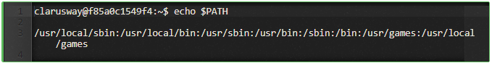

The special character $ can also be used with the user's custom element. For example, in the bash shell, the user can define an element like greeting="Hello from Clarusway" and extend the value of this element as shown below.

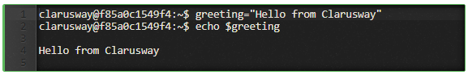

There are three types of quotes:

1. **Double Quotes** : The double quote " preserve the literal value of most characters contained within the quotes, exceptions include $ (for variables), ' (for single quoting), \ (for escaping a character) .

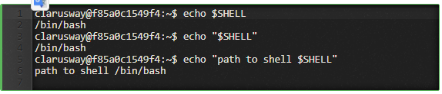

1. **Single Quotes**: The single quote ( 'quote' ) protects everything enclosed between single quotation marks.

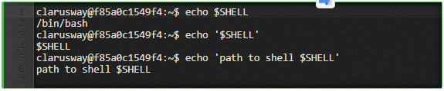

1. **Backslash**: Use the backslash to change the special meaning of the characters or to escape special characters within the text such as quotation marks.

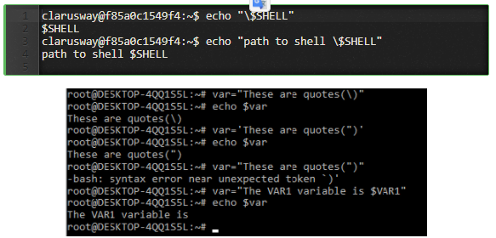

### File Permission

### Linux File Ownership: Each file and directory on Linux system has 3 types of owners assigned,

* **User:** A user is the owner of the file.
* **Group:** A user- group can contain multiple users.
* **Other/All:** Any other user who has access to a file.

### Permission: Each file and directory on your Linux system has 3 permissions defined for all the 3 owners.

* **Read (r) :** The read permission gives you the authority to open and read a file.
* **Write (w) :** The write permission gives you the authority to modify the contents of a file.
* **Execute (x) :** In Linux, you cannot run a program unless the execute permission is set.
* **No permission (-)**

|  |  |
| --- | --- |
| Basic Command | Basic Command  Basic Command |

**Changing Permission with chmod Command**

* We can use the chmod command which stands for **change mode**.
* Using the command, we can set permissions (read, write, execute) on a file/directory for the owner, group and the world.
* Kodun kullanım şekli: **chmod permissions filename**

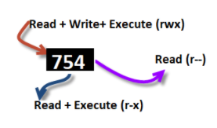

### Ping & SSH Command

### Ping Command

* Ping or Packet Internet Groper is a network administration utility **used to check the connectivity status between a source and a destination computer/device** over an IP network.
* It also helps you **assess the time it takes to send and receive a response** from the network.

ping host-name/IP

ping 54.93.34.220

Press CTRL+C (in MacOS => CMD+C) to exit.

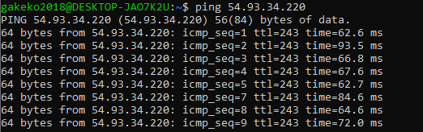

### SSH

* ssh stands for “Secure Shell”.
* It is a protocol used to securely connect to a remote server/system.
* ssh is secure in the sense that it transfers the data in an encrypted form between the host and the client

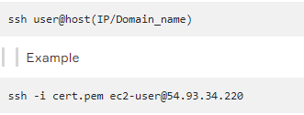

### whoami Command

* Displays user, group and privileges information for the user **who is currently logged on to the local system**.
* whoami command **is used both in Lunix Operating System and as well as in Windows** Operating System.
* It is basically the concatenation of the strings “who”,”am”,”i” as whoami.
* Girilecek komut: whoami

### Man Pages

* A man page (short for manual page) **is a form of software documentation usually found on a Unix or Unix-like operating system**.
* Man pages are the traditional package documentation for application usage. What that means is that they're typically installed when you install a package. So if we install a package to do some task, the man page for that package will typically be installed at the same time**. This gives us the ability to take a look at that documentation and make sure that we're using it in a manner consistent with its design**.
* The man page for a particular command is invoked by preceding the command with man.

man <command>

man ls

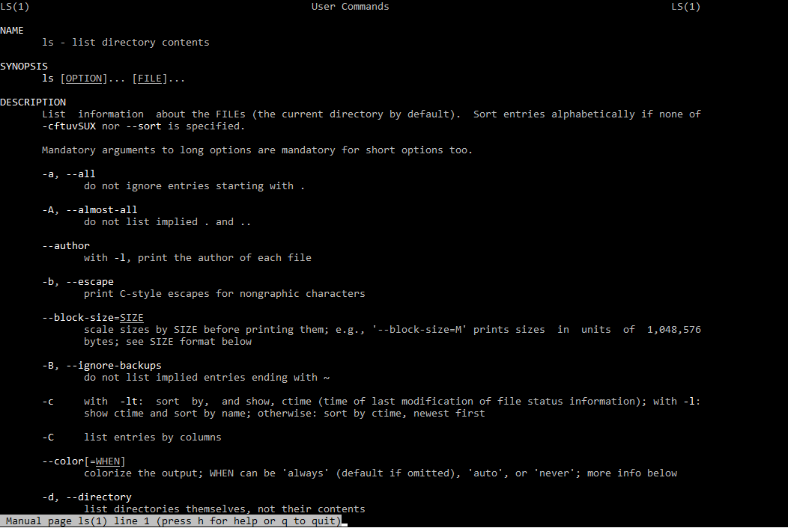

### Name : Program or Function name(s) followed by descriptions of functionality.

### Synopsıs : A short overview of available options

### Descrıptıon : Detailed information about arguments and options.

### Info Pages

* Info pages are additional documentation with more robust capability in detail.
* **Info Page normally provides more detailed information about a command than its respective man page.**
* Additionally, Info uses a structure for linking these pages together, and they may be assembled into a larger collection.
* The info page for a particular command is invoked by preceding the command with info.

info <command>

info echo

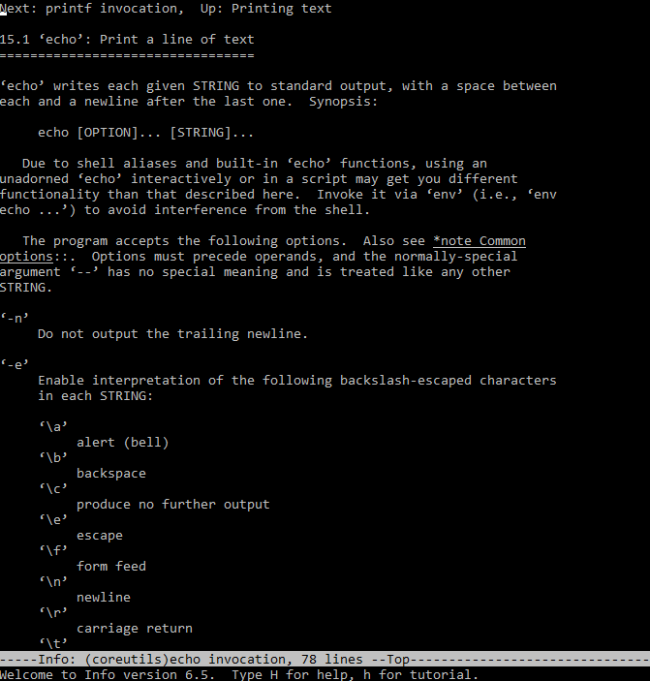

**The main difference between Man and Info** is the amount of content that they have; Info contains a whole lot more than Man does.

**LİNUX DERSİ VİM EDİTÖR**

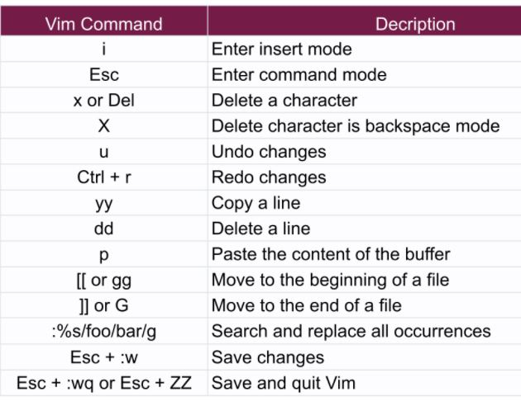

**LİNUX DERSİ NANO EDİTÖR**

